INTERNAL NOTE

Ref.: MKCL/CMP/2025/04
Date: December 11, 2025
Subject: Request for Approval of Sponsorship of ₹1,00,000 to Action for Agricultural Renewal in Maharashtra (AFARM)
To,
The Managing Director
AFARM (Action for Agricultural Renewal in Maharashtra), established in 1969, is one of the oldest and most respected NGO networks in the state, focused on Sustainable Rural Livelihoods.
AFARM has invited Maharashtra Knowledge Corporation Limited (MKCL) to join their upcoming Maharashtra Rural Livelihoods Summit 2026 as Associate Thematic Partner. The Summit is scheduled for January 28-29, 2026, at YASHADA, Pune.
As Associate Thematic Partner AFARM has requested MKCL's participation to support them by providing following
- Financial Sponsorship: Contributing ₹ 1,00,000 (Rupees One Lakh only)
- To lead the thematic session on Digital Technology Inclusion in the Summit
This partnership provides a valuable opportunity for MKCL to showcase its technical expertise, field experience, and innovative insights to a key state-level dialogue, especially in the field of Agriculture and Livelihood.
The Managing Director is requested to approve, if found appropriate, the amount of ₹ 1,00,000/- for Sponsorship to AFARM.
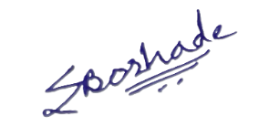
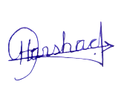
Prepared by Proposed By Vetted by
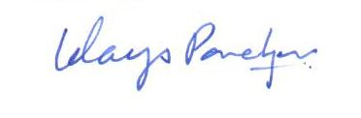
Harshad Tidake Uday Panchpor Swati Borhade
MIS and Data Senior General Manager, Manager Analytics, Manager Corporate Management Program (CMP) Accounts 11-12-2025 12-12-2025 18-12-2025

Recommended by Approved by

Komal Chaubal Sameer Pande
CEO & CS Managing Director
__-12-2025 __-12-2025

